**Feedback Report**

**NWMCWC – Dervaig Hall Community Listening Event 7th August 2024**

23 people from the community attended

2 NWMCWC Directors – Anne Cleave and Tracy Mayo.

Lynn Molleson and Laura Worku, DTAS

Context:

DTAS (Development Trust Association Scotland) is a member-led network of enterprising charitable community organisations (https://dtas.org.uk/). Started 21 years ago, we now have a network of 345 community development trusts spanning Scotland, taking in islands, rural and urban communities. The term ‘community development trust’ came to mean something distinct: representing a geographi community; being member-led; engaged in enterprise; acting as a community anchor bringing in funding; developing an action plan and strategy in collaboration with the local community.

NWMCWC joined DTAS in May 2013, having been set up in 2006 to purchase and manage the Langamull and West Ardhu forests in North West Mull. In 2018 the trust was successful in a community buy-out of the Island of Ulva. As a charitable company run by a small team of volunteer Directors, they have a large and demanding portfolio of projects.

Issues affecting NWMCWC are affecting many communities and development trusts across Scotland: an ever-increasing demand for their time and services against a back drop of escalating costs, diminishing funding and in communities where many people are anxious about the on-going cost of living crisis. The buy-out of Ulva was particularly impacted by the pandemic and the on-going impact that had on funding for the capital projects there, along with other communities in similar geographies: housing in poor condition and the inflated cost of capital projects on islands, along with the difficulty of securing contractors.

In discussion with the NWMCWC Board, who recognised that relationships with the community had suffered in the years that they have been firefighting to keep the large projects afloat – namely the woodfuel company and the work since the buy-out of Ulva – DTAS offered to host 2 pre-AGM community meetings: one on Ulva and one in Dervaig. These had to be held right in the middle of peak tourist season and we are especially grateful for the generosity of the people in attending these meetings, giving up their time and participating so openly and honestly. We want to particularly highlight the dedication of all the Board Directors but without the bravery and support from Anne and Tracy, these meetings would not have taken place. They were willing to put themselves in a difficult position, hearing negative views of the trust and board, despite their hard work and exhaustion. Thank you to the community in the hall in Dervaig who gave Anne and Tracy an appreciative round of applause.

Process:

After a more general discussion of why the meeting was being held by DTAS, as a pre-AGM community listening exercise, people were given post-its and asked to list Positives, Issues and Ideas about the work and mission of NWMCWC.

The charitable purposes of the trust are:

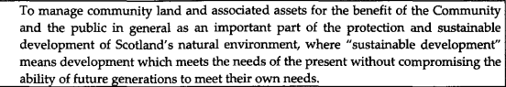

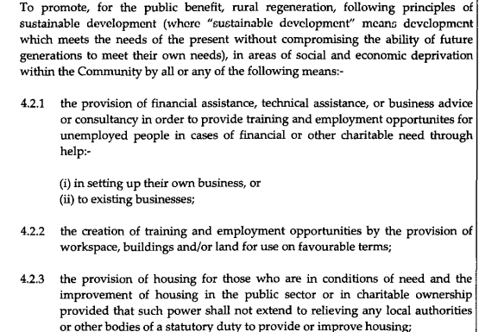

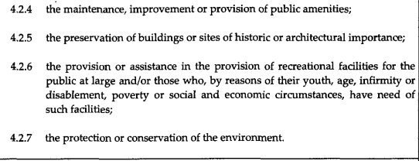



[The full list of post-its generated are in the Appendix]

Following this exercise, a general discussion was held around the key themes, issues and ideas emerging.

**Key theme One – the complexity of managing the woodlands and Ulva –**

In general, there was a recognition that this was potentially overwhelming for one organisation.

Could these large projects be separated? – this would be difficult with the buy out titles for Ulva and the funding sitting with the current trust. However, use of subgroups with clear missions and delegated authority from the Board could work better, allowing people not on the Board to get involved in Ulva and the Woodfuel business and help spread the load. The growing community on Ulva may wish to self-manage in the future.

**Key theme Two – maximising the woodland for local benefit –**

The woodland and the wood fuel business were the primary focus for the people in the meeting, namely securing a wood supply for local winter demand.

Phytophthora in the forestry area has had a massive impact on the woodfuel business. In the room there were suggestions around how to mitigate this – bringing a debarking machine to the island to remove the bark, allowing the core wood to be used locally; working with the trust to influence decision-makers to look specifically at this case and allow a license for commercial sale and export. Also plenty of suggestions around how the community would like to engage with the woodland (beavers; access for walking and cycling; a forest school/nursery business; burial site; woodland lots; more woodland crofts)

**Key theme Three – Communication**

The issues around communication come up very strongly (likewise in the Ulva meeting). The board has been overwhelmed and communication has suffered. Suggestions focussed on the need for regular updates and honest and open discussion with the community. Starting with a membership drive. Around half the people in the room were members of the trust. Upgrading the website and adding a web form would be the easiest way to start a membership drive (also having application forms in the shop). In the meantime, people can join by contacting Amber – [admin@nwmullwoodland.co.uk](mailto:admin@nwmullwoodland.co.uk) – to request a membership form. The trust does not have much of a physical presence in the village anymore. A regular newsletter or column in Round and About would also help. Use the village notice board. Ask for help.

**Key theme Four – Mission**

The purposes are very long and wordy, people felt they were hard to grasp or understand what they are specifically focussing on. They are also high level and a strategy is needed for 1-5years, with realistic and deliverable objectives for each key strand (Ulva; the wood fuel business; broader project work).

Is the structure of NWMCWC fit for purpose?

There was a suggestion of a Mull-wide conversation. There are 4 development trusts on the island with a further trust just on Iona, 4 are members of DTAS- NWMCWC; MICT; SWMID and Iona Renewables- with the addition of the Tobermory Harbour Trust. This conversation could look at all the assets and resources on Mull, Iona and Ulva.

**Appendix – List of post-its generated at the meeting**

Ideas:

Community shed/workshop for the village

Mountain biking tracks; cycling tracks; walking tracks

Can wood for stoves be imported if there is none for sale on Mull? [wood from SWMID Trust?]

Development of community woodland amenities

Woodland burials

Winter 2026 – larch supply available (after die back lie time)

Employment schemes with the school [already happening- more details for a newsletter?]

What is the trust’s vision for the woodfuel company? [main question in the room]

Debarking machine [needs investigation – could free up the wood supply, leaving the bark for 2 more years]

Democratise the trust – talk to people- engage the community

Firewood strategy for local supply – coppicing?

Wildflower areas

More woodland crofts

Separate out Ulva and offer to MICT

Support to change the wood export policy [‘we would write to the MSP if you tell us what is needed’]

Diary of events and forward planning linked to website

Issues:

Refusal of help when offered to the Trust so no point in trying. Feels like a closed shop

People are too prepared to criticise and not to offer constructive help

Crofts?

Complete lack of information and transparency- no public minutes for 5 months; no communication or newsletters; no community engagement.

Website lacking in key info

Wood delivery – need the crane lorry to deliver to my property

A similar meeting to this one about Ulva House had no follow-up

Lack of clarity – particularly around the finances of the woodland company

Lack of accessibility – how to get to Ulva? How to get round UIva? Signs with the distances clearly marked.

Too much focus on Ulva – forest has been left behind

Lack of communication with the NW Mull community

Timber to be utilised locally

Woodfuel business – expensive plant, external stalkers

Usable local wood supply

What is the actual benefit to the community of the trust?

Ulva business development assistance needs upgrading and rent processes more transparent and fair

Poor state of Ulva church, Ulva House, Sheila’s cottage, woodshed

Maintenance of Ulva buildings

Telford church condition survey and plans for the future?

When first moved here 12 years ago there was talk of a woodland burial site and nothing has happened

Housing and challenges

Lack of transparency in Directors’ decisions and only a small membership

Wind turbine refused after community vote

Reinstating former Directors when barely quorate rather than going out to the community

Woodland needs more focus

Existence of subcommittees- who are they and what do they do?

Mission too long?

No community involvement

Lack of people wanting to be involved at Board level because of challenges

What is the focus of the trust?

Positives:

Forest crofts

Micro hydro

Setting up the jetty to get the timber exported more sensibly

Job creation

Regeneration of the dilapidated housing stock on Ulva

Creation of crofts and public toilet

Steady local employment

Haulage route set up

Provision of timber for local construction and fuel

Purchase of Ulva

Opening up Kildarie – archaeological training

Creation of jobs in NW Mull and on Ulva

Childrens woodland garden

Hydro generator

Replacement of crumbling pier at Ulva Ferry

Supply of quality woodchip to local businesses using RHI

Broad leaves planted

Treestory work and replanting

Local jobs

Hydro plant

Fantastic objectives – broad realising

Creation of local jobs

State what has been achieved

Acquisition of Ulva – bringing people in

Forest crofts

Facilitated the purchase of Ulva for the community

Built the haul road to enable harvesting

Improvement of housing stock on Ulva

Facilitated the harvesting of mature forestry that would otherwise have been wind blow

Created the right environment for the Fishnish timber pier to happen