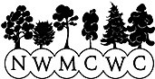

**NORTH WEST MULL COMMUNITY WOODLAND COMPANY**

**BACKGROUND FOR MEMBERS AHEAD OF AGM**

**AUGUST 2024**

**INTRODUCTION**

It’s getting close to 20 years since NWMCWC was founded, and whilst most of the people who’ve been involved over the years either as volunteer directors or employees are still within the community (and some are still involved), there will be many in the community now who are not familiar with our Community Company’s work or the background.

There is a sense that the Company is at something of a turning point and that we need re-engagement and renewal to maximise future benefits for the community from the land management and business activities that are carried out on its behalf.

Our two main activities, namely management of the woodlands and development of the Isle of Ulva have both reached the stage where most of the critical priorities that came with the community buyouts have been tackled. For example, the woodlands have been felled and replanted to set up the next rotation. On Ulva, the existing housing stock has been renovated, farming is back on the island and potential new housing is in the pipeline. There have been many other achievements, some of which are detailed below, but the overall picture is that of a solid foundation on which to base a new phase of community-led developments.

This report aims to provide some of the background and provide a sense of the scale of what is now a significant community business - amongst the largest in Scotland - with an asset base in the order of £8M and a very diverse range of activities.

**The challenge to members of NWMCWC and the wider community, is to find a new generation of directors and supporters to take the Company forward over the next 20 years and beyond.**

The next AGM is scheduled for Monday 9th September and nominations for election of directors are invited. These must be proposed and seconded by members using the form in appendix 1 and received by 7pm on Monday 2nd September.

In addition to directors elected from the membership at the AGM, we are also able to coopt anybody with particular skills or experience at any time.

Anyone interested in becoming a Director is encouraged to get in touch with any of the current Board.

|  |  |
| --- | --- |
| Anne Cleave: | anne@nwmullwoodland.co.uk |
| John Addy: | john@nwmullwood.co.uk |
| Ian Hepburn: | ian@nwmullwoodland.co.uk |
| Tracy Mayo: | tracy@nwmullwoodland.co.uk |
| Colin Morrison: | colin@nwmullwoodland.co.uk |

**THE COMPANY**

The Company objectives are set out in the Articles of Association…

|  |
| --- |
| ***To promote, for the public benefit, rural regeneration, following principles of sustainable development (where “sustainable development” means development which meets the needs of the present without compromising the ability of future generations to meet their own needs), in areas of social and economic deprivation within the Community by all or any of the following means:-***  · ***Provision of financial assistance, technical assistance, or business advice or consultancy in order to provide training and employment opportunities for unemployed people in cases of financial or other charitable need through help:- (i) in setting up their own business, or (ii) to existing businesses;***  · ***Creation of training and employment opportunities by the provision of workspace, buildings and/or land for use on favourable terms;***  · ***Provision of housing for those who are in conditions of need and the improvement of housing in the public sector or in charitable ownership provided that such power shall not extend to relieving any local authorities or other bodies of a statutory duty to provide or improve housing;***  · ***Maintenance, improvement or provision of public amenities;***  · ***Preservation of buildings or sites of historic or architectural importance;***  · ***Provision or assistance in the provision of recreational facilities for the public at large and/or those who, by reasons of their youth, age, infirmity or disablement, poverty or social and economic circumstances, have need of such facilities;*** · ***Protection or conservation of the environment.*** |

Membership is open to anyone living within NW Mull as defined by a list of post codes set out in the Articles. Associate membership is available to anyone outwith our postcode areas. Currently we have around 150 full members and 35 associate members. On behalf of the membership and in accordance with the Articles, an elected board of directors runs the Company augmented by co-opted directors with particular skills and experience as necessary.

NWMCWC is a registered charity.

# WOODLANDS

## Forest Purchase

The large blocks of forestry around Dervaig in North West Mull were planted by the Forestry Commission 40 to 50 years ago, presumably with an assumption factored in that when needed a way would be found to get the timber out to the market. In the case of West Ardhu and Langamull woods several possibilities were looked at by the Forestry Commission but not very seriously or successfully. So, when it became clear around 2000 that the by now mature crop was effectively land-locked, the Commission started to think about selling it so someone else would have to worry about finding a solution before it became over mature and at risk of blowing down.

When the prospect of a sale became known, the view quickly took hold in the community that the woods had great potential to deliver community benefit and the best way to achieve that would be to have them in community ownership. In 2005 a group was established to organise a bid to purchase the woods under the recently established National Forest Land Scheme (NFLS) and the North West Mull Community Woodland Company (NWMCWC) came into being.

A business plan was prepared to support the bid for funding under the NFLS and the very wide support from the community as evidenced by packed public meetings in the village hall and various fundraising initiatives provided crucial support to the application.

Together, West Ardhu and Langamull totalled around 700ha of mature plantation and a discounted purchase price of £343k was agreed, reflecting the fact that the timber was land-locked because timber lorries were not allowed on the fragile local public roads.

For a new community organisation starting from scratch putting together a funding package and gaining the necessary approvals was a major task. The funders were the National Forest Land Scheme and the Scottish Land Fund, Highlands and Islands Enterprise (HIE), the Robertson Trust, the Hugh Fraser Foundation’s and also an interest free loan.

Purchase of our two woods in 2006 was the first achieved under the NFLS, narrowly beating another community group seeking to buy a block of forestry over on Deeside in Aberdeenshire.

## Haul Road

Community ownership of Langamull and West Ardhu woods provided a new impetus to deliver a practical export route of the timber and we were on a steep learning curve as a project was put together comprising new tracks and reinforcement of a stretch of public road.

A route was mapped out from North Langamull, crossing the Dervaig to Calgary road, through South Langamull and then over the hill to enter at the top of West Ardhu high above Druimgigha. Then down the hill, crossing the bottom of the Dervaig to Torloisk hill road and out along the Kengharair track, leaving the community woods below Kengharair House before heading up the West side of Glen Bellart to join the Forestry Commission’s network of tracks at the watershed between the Bellart and Aros Glens.

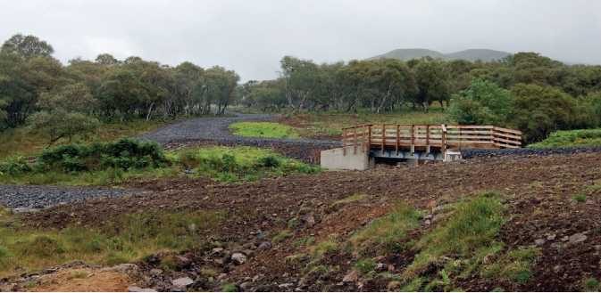 **Haul route in Glen Bellart**

## Unforeseen challenges

It was by no means plain sailing throughout the haul route project, particularly in terms of project scope and costs. The route connecting Langamull with West Ardhu, and then onwards to link up with the Forestry Commission, crosses the land of three private owners. Agreement was reached initially with all three that we could cross their land at no cost. (Though one owner requested a free annual supply of firewood which we readily agreed to). However, when ownership of one part of the route changed, the new owner insisted we pay to cross their land which added £43200 to the project costs and also imposed a requirement to pay a tariff on timber from Langamull in future rotations - an unwelcome burden on future generations of the community. A further complication took both ourselves and the Forestry Commission by surprise when it emerged that one bank of the River Bellart was owned by a fourth private landowner who in this case demanded an unacceptable tariff in perpetuity on all timber crossing what was effectively his “ransom strip”. This forced us to build additional road to reach Forestry Commission land at a cost of £152000, of which we had to find £60000 with the remainder coming from the Scottish Government.

Although the haul route benefitted from Scottish Government and ultimately European funding via the Scottish Strategic Timber Transport Scheme, we needed to contribute a proportion ourselves which had to be raised from timber sales. Therefore, the additional unanticipated costs above represented a serious squeeze on the budget for subsequent refencing and restocking as required by the Forest Management plan.

Construction of the haul road was a massive undertaking for the newly formed Community Company and relied on limited project management and admin staff supported by volunteer directors. Its successful completion was a credit to all those involved and more importantly a vindication of the community’s vision and the hard work put in by many people to buy the woods in the first place.

The haul road facts and figures are summarised in the table below.

|  |  |  |  |
| --- | --- | --- | --- |
|  | **Cost £** | **SSTTS**  **Grant**  **£** | **Net Cost £** |
| NWMCWC Construct 16.5km road & 4 bridges | 1,202,050 | 512,330 | 689,720 |
| Landowner support in kind (mainly access rights) | 260,360 |  | 260,360 |
| Argyll & Bute Council reinforce 3km of public road | 820,000 | 348,400 | 471,600 |
| Forestry Commission new link track | 77,500 |  | 77,500 |
| **TOTALS** | **2,359,910** | **860,730** | **1,499,180** |

## The next steps

With an export route in place, the next tasks were to finalise the Forest Design Plan (FDP), obtain its approval and then organise a phased felling and restocking programme. Various iterations of the FDP culminated in the present plan. Whilst retaining a major commercial timber element, the plan also calls for a much greater emphasis on native broadleaf woodland and amenity value than would be the case in typical commercial or investment-led plantation woodlands. We also obtained accreditation from the UK Woodland Assurance Scheme and of course had to pay our share of the haul road costs from the harvesting.

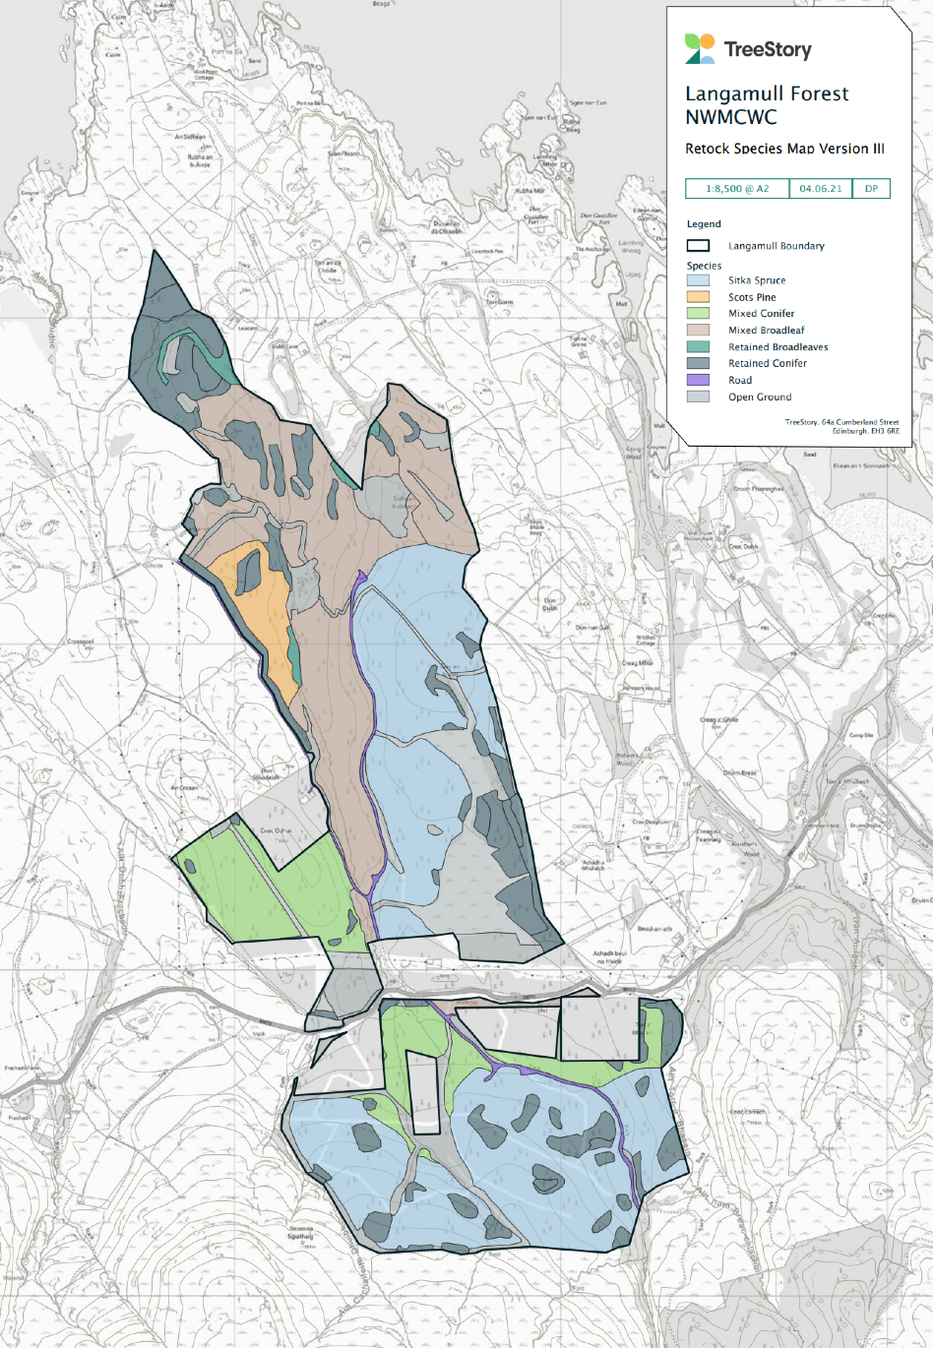

**Langamull restock plan showing increased area of native broadleaf and open ground**

## Timber Pier

Construction of a permanent timber export pier on the Sound of Mull had been mooted for several years, and the need to export our estimated 130000 tonnes added significantly to the justification of providing this facility for the whole of Mull. Nevertheless, the facility at Fishnish took longer than expected to be built and in the interim a floating pier was used to export the earlier tranches of our timber.

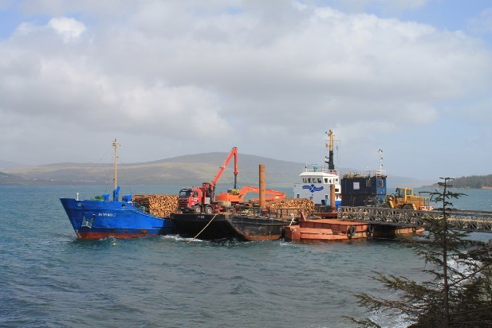

**Prior to the new Fishnish facility, export was via a floating pier**

## Restocking

Given the investment required to construct the haul route, the complexities outlined above and the volatility of the timber market, it was always felt that to break even in this first rotation would be a significant achievement. The priority was to be financially neutral or even slightly positive to set things up for the second rotation.

As of summer 2024 the only outstanding felling and restock is our “Phase 2” across the valley from Dervaig at the bottom of the Hill Road and running behind the SSE Substation.

Because of its proximity to Dervaig, and the potential for new housing in the area (see below) the focus here will be on amenity woodland, mostly native tree species and mostly achieved by natural regeneration.

Completion of Phase 2 combined with restoration of the Bellart bog (see below) is projected to achieve cost neutrality or even slight surplus on the first rotation since the woodlands were purchased.

## Forest Crofts

The nine Forest Crofts established in Langamull woods were approved by the Crofting Commission in 2011 and are the first in Scotland. These are signed over to local people to work as crofts whilst maintaining a minimum of 80% canopy cover. The crofts are now at various stages of development with a range of objectives including forest smallholding, market gardening and a tree nursery.

Our pioneering work setting up forest crafts has provided a model for similar initiatives elsewhere in Scotland

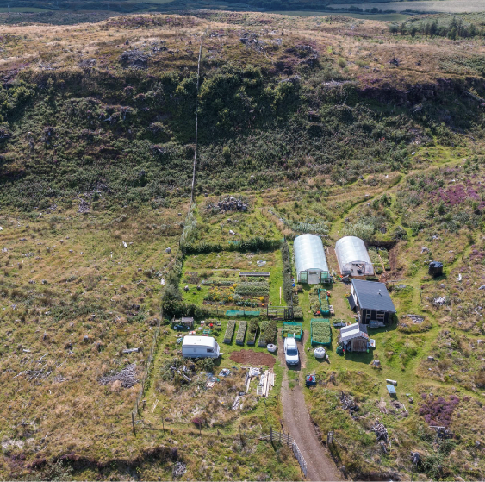

**Andy Robinson’s croft and tree nursery in Langamull. Photo Carolyne Charrington**

## Amenity

The great potential for development of woodland amenity activities was recognised from the outset and a detailed Feasibility Study in 2011 set out a wide range of possibilities including wildlife tourism, waymarked footpaths, downhill mountain biking, campsites etc.

Now that the first rotation felling and restock has been completed and the ground is clear, that Feasibility Study needs to be revisited and some of the recommended projects implemented.

## Bellart Bog

The plantation below Druimnacroish on the Glen Road should arguably never have been planted, particularly in the boggy parts where deep drainage ditches had to be dug and where access is still very difficult. Blanket Bogs in Scotland and elsewhere are now regarded as significant carbon sinks with an important role to play in tackling climate change. Plans are being developed and funding sought to restore the bog.

## Woodfuels

In 2013, through our subsidiary, NWMCWC Trading Company, we purchased an existing local woodchip supply business and expanded production of cut and split firewood. Over following years, a large woodfuel processing and storage shed was constructed and the necessary machinery, handling and delivery equipment purchased.

There is no doubting the potential to develop the woodfuel business further, but in common with other woodfuel suppliers on Mull, we are currently faced with an acute shortage of wood for processing. Given the amount of timber grown on Mull this seems perverse, but two factors are contributing to what we hope will prove to be temporary difficulties. Namely, prohibition of timber movement due to the fungal disease of larch die-back (Phytophthora ramorum) and the high current market prices for Sitka spruce sawlogs leading to a scarcity of that timber for chipping on Mull.

We are so far managing to find work-around solutions to these problems and are hopeful that in the next year or two our woodfuel business will be able to turn the corner from ticking over in survival mode to becoming a significant revenue stream supporting the Company’s core costs.

**Micro Hydro.**

We are fortunate to have a reasonably reliable burn running though the West Ardhu woodland and after a protracted planning and permitting process a micro hydro-electric scheme was installed and has been running for the past three years.

Operating under the auspices of a wholly-owned subsidiary called Ardhu Power Limited, the net annual income from our micro hydro scheme is around £30k which goes a significant way to covering the basic administrative costs of the parent Company.

## Woodland Housing Potential

Support for local housing is one of the Company’s core objectives and we successfully campaigned for the designation of a Potential Development Area (PDA) for housing in the Argyll and Bute Local Plan. This is in our woodland closest to Dervaig and has the potential for a significant number of houses. We are currently working with Argyll Community Housing Company on the feasibility of building four houses for affordable rental along the roadside and once the final phase of felling is completed, we will start looking at the potential for marketing building plots elsewhere in the PDA.

It is well known that there is a housing crisis on Mull driven by the high prices resulting from Mull’s popularity with tourists and holiday homes. In response to this, both at Dervaig and on Ulva (see below), whilst seeking full market value for some plots to finance infrastructure we are also open to discussion of mechanisms such as discounted plot prices coupled with shared equity to support affordable new builds. In addition to the PDA in West Ardhu, we are also considering sale of plots in North Langamull.

**ISLE OF ULVA**

## Background to the community buyout

When word got out that the Isle of Ulva was going to be sold and particularly when it became clear that a significant part of the marketing strategy was to pitch Ulva as a private sporting estate there was great concern within the community of North West Mull. It was therefore decided to put together a bid to purchase the island for the community using the Scottish Government’s Community Right to Buy Legislation.

This was not a straightforward process. A huge amount of work was required to define and articulate the vision for the island’s future, demonstrate community support and put together a funding package.

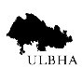

***The Vision for Ulva***

***Provide sustainable benefits for the community including the repopulation and re-generation of the island in the short, medium and long term.***

***To achieve this an ambitious development programme was initiated to:***

· ***Improve housing stock and other buildings***

· ***Improve infrastructure***

· ***Revitalise and expand agriculture***

· ***Manage woodlands sustainably and seek opportunities for creating further broadleaf woods***

· ***Unlock the very large tourism potential largely untapped at present***

· ***Care for and promote the cultural heritage of the island***

· ***Enhance biodiversity and conserve sensitive habitats and species***

· ***Safeguard natural habitats of the isolated associated islands and skerries***

· ***Support Marine Industries, Fishing and Aquaculture***

· ***Ensure the island remains accessible for visitors and residents***

The vision for Ulva was endorsed by the Scottish Government when it approved our Community Right to Buy application. Subsequently, having studied the detailed Business Plan for the island, the Scottish Land Fund approved a grant of over £4M to complete the purchase. This was further supported by a donation of £500,000 from the Macquarie Group and a number of community fundraising activities.

The official handover of Ulva to the community took place on 21st June 2018. Whether or not it was intended, this happy coincidence with midsummer’s day as the annual anniversary of Ulva’s very own “Independence Day” will hopefully be celebrated by generations to come.

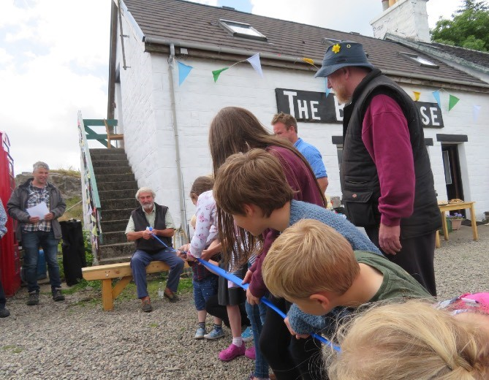

**Cutting the ribbon on Ulva’s independence day**

## Housing Strategy

Repopulation of Ulva and the island’s social and economic development of Ulva has an important role to play in sustaining and growing the remote and fragile community of Ulva Ferry and North West Mull. A key message to support the buyout was that Ulva is a part of and not apart from its larger neighbour.

The route to achieving repopulation has four strands; Renovation of existing houses, Renovation and repurposing of Ulva House and Ardalum House, Redevelopment of derelict buildings, and New Builds.

The above approach was set out in a Masterplan which was approved by Argyll and Bute Council in 2020 which effectively provides Ulva with its own planning framework sitting within the broader Local Plan for NW Mull.

**Renovations:** At the time of the buyout, all six existing houses on Ulva were in a poor state of repair, some shockingly so. Their renovation, which entailed complete strip out in most cases was the first major development project on the island. This was successfully completed a couple of years ago and all are now occupied. Affordable rentals are benchmarked against comparable social housing on Mull.

**New Housing:** The Ulva Masterplan sets out the potential for up to 10 new build houses and perhaps another 6 or more houses on redevelopment sites. We are currently working with Argyll Community Housing Association (ACHA) on a Feasibility Study looking at 5 potential new houses above the Boathouse and Slipway area. Separately we have obtained Outline Planning Permission for houses on 5 of the new build sites, two of which we are being marketed this summer. The aim is to seek full open market

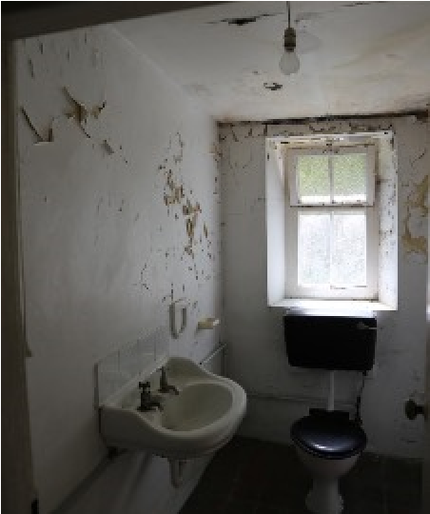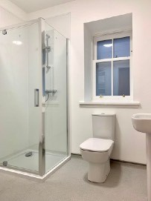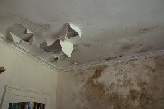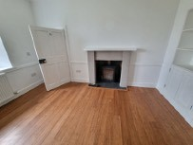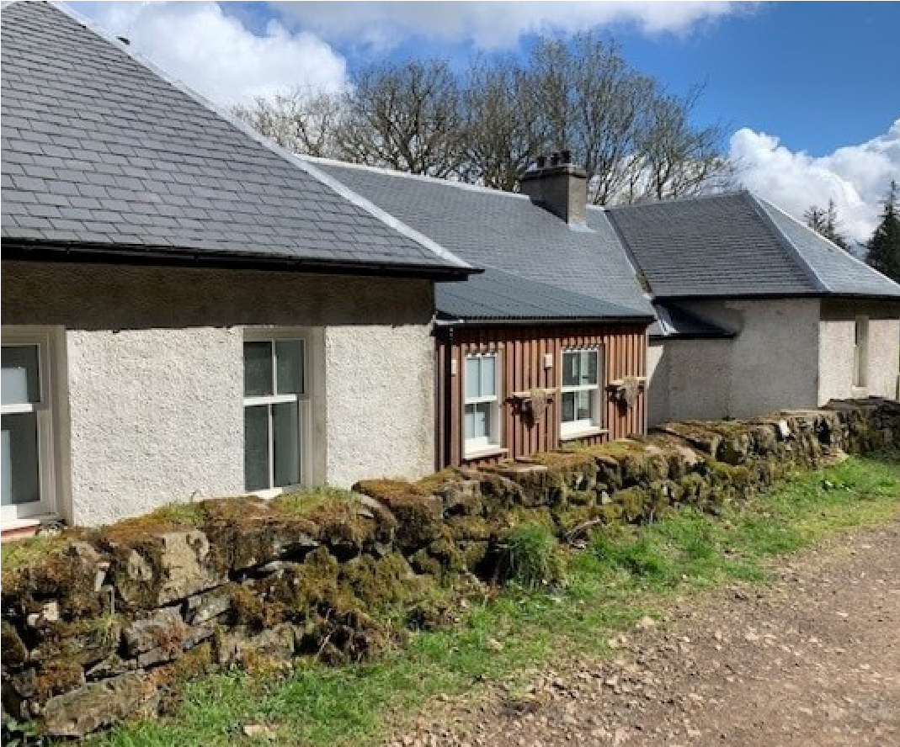

### The Manse. Some before and afters

value for these first two plot sales to help finance infrastructure improvements or contribute towards new build rental property of our own. Regarding future plot sales, we are open to discussion of schemes such as shared equity to help people, especially the young to live on Ulva and contribute to its development.

**Island population targets:** For years under the previous ownership the number of residents of Ulva saw a steady decline so that at the time of the buyout there were just five residents of which two were young children. With the old houses now renovated and leased at affordable rental levels, the population now stands at sixteen. As plans to develop Ulva House, build community housing, enable private new-builds and redevelop existing sites come to fruition in coming years it is realistic to envisage a total population eventually reaching between 50 and over 100 people.

|  |
| --- |
| ***Repopulation potential (from Masterplan)***  ***Residents***  ***House renovations 16 - 28***  ***Repurpose existing buildings 1 - 8***  ***Redevelopment 12 - 22 New builds 21- 44***  ***TOTAL 50 - 102*** |

**Infrastructure improvements:**

**Piers.** The pier on the Mull side is hugely important to the local fishing industry and emergency repairs were carried out on it and the slipway on Ulva. Funding was later secured to carry out major improvements to the pier iwhich provide access to slightly deeper water and enable two local fishing boats to use the pier at the same time.

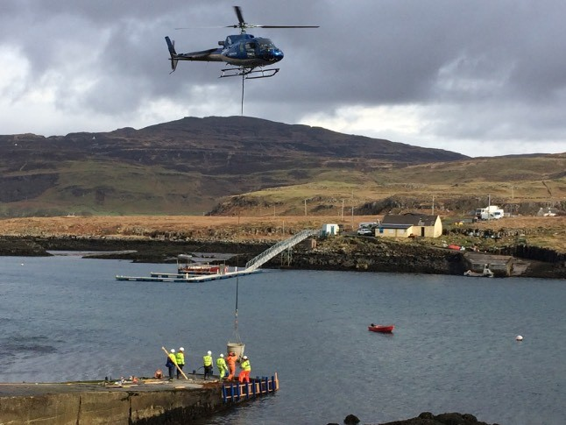

### Slipway improvement. Concrete delivery

**Water Supply.** The water supply on Ulva has problems with quality and capacity which need to be sorted out to meet both existing and planned future demand. A three-stage approach has been taken. Firstly, the old reservoir has been cleaned out and reinstated as the primary source. This work was undertaken in 2023. A completely new and much greater capacity filtration and purification plant is planned for 2024 funded by Argyll and Bute Council and finally, a new and bigger diameter water main will be laid to supply existing and new properties in the east of the island, hopefully in 2025/26

**Business development.**

The general approach taken by the Company is to enable and facilitate business development on Ulva rather than seek to operate its own enterprises.

**Ferry.** The Ulva Ferry is the only public service ferry in Argyll and Bute which operates without some form of subsidy. Family run for many years it is an essential lifeline for the island. As the population and activity on Ulva increases it will be important to ensure this vital link keeps pace with demand. Not only in relation to foot passengers but also for larger freight, machinery, bulk materials, livestock etc. There is an ambition eventually for Ulva to have its own transport capacity. In the meantime we are extremely grateful for the logistical assistance we have received from the neighbouring fish farm.

**Boathouse restaurant.** The successful and highly regarded restaurant operates under a lease from the Company. It provides employment, supports local producers including fishermen and attracts many visitors to the island.

**Hostel.** Ardalum House operates under a Repairing Lease from the Company. Major renovation works including complete rewiring having been completed by the tenant, the hostel is now fully up and running, providing popular and much needed visitor accommodation.

**Bothies.** On the North side, Bearnus bothy has been renovated by the tenant and is running successfully as an off-grid visitor experience. Cragaig bothy on the South side was given a televised makeover in 2023 and is currently let via a booking agency on Mull. Further repairs including a new roof are needed and its likely that in future it will be taken on under a repairing lease by one of the Ulva residents on a similar basis to Bearnus bothy.

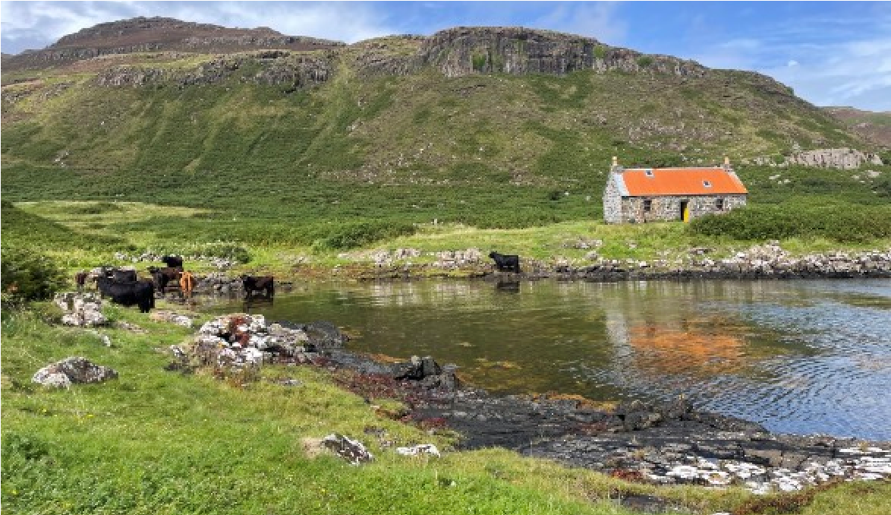

### Cragaig bothy

**Ulva House.** In common with many community landowners in Scotland, we were faced after the buyout with the question of what to do with the “Big House” that came with the land. Whilst accepting that this listed building needed to be protected, it was recognised that it represented a major drain on the island’s finances unless a solution could be found. The challenge from the outset has been to find a way to view it as an asset and opportunity rather than a liability.

A proposal to establish a heritage centre came close to fruition but had to be cancelled when hit by rising material and labour costs following Brexit compounded by the Covid pandemic.

Consultation with the community established support for us to seek alternative uses but expressed a preference to lease rather than sell the building. We have therefore been working with prospective tenants on an ambitious plan to repurpose Ulva House as a boutique guest house and restaurant.

**Ulva House awaiting restoration and a new future**

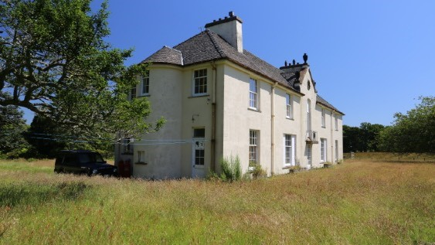

**Farming.** Re-establishing agriculture on Ulva was a central theme from the outset, and it was also strongly believed that this needed to be within the context of conserving and enhancing Ulva’s remarkable natural heritage and biodiversity. Farming in less favoured areas such as Ulva is challenging enough without the added logistic problems of an island off an island, so after consulting local farmers and agricultural advisors, we decided to let the whole farm in one package rather than splitting up the ground.

To kick start the process whilst we sought a suitable tenant farmer and also take advantage of funding under a Scottish Government Agri Environment and Climate Scheme (AECS) we took the step of buying a starter fold of highland cattle and then a bull.

With support and advice from the Scottish Government’s Land Matching Service and local farmers and advisors we advertised the tenancy and in 2023 were delighted to sign a lease with the current farming tenant.

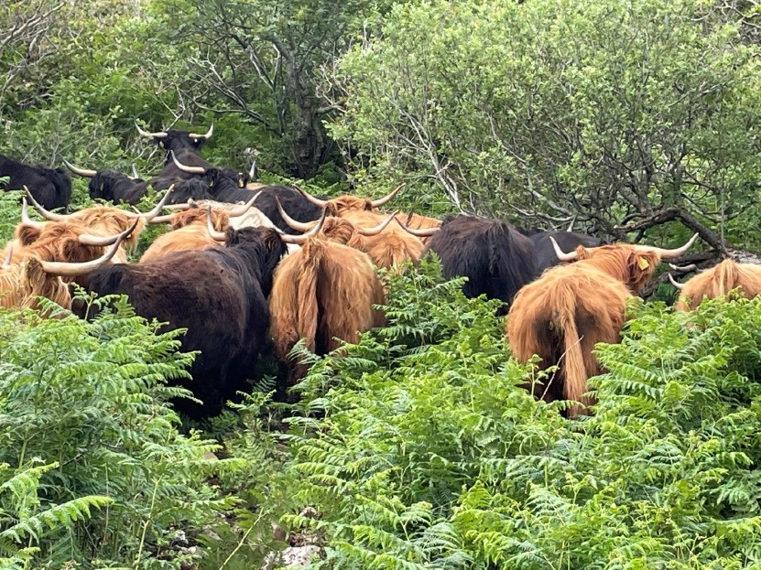

**Free ranging cattle have an important role in suppressing bracken and improving biodiversity.**

**Potential.** It is still early days and there is great potential for new business development on Ulva. Wildlife, Tourism, Agri tourism, Smart Clachan, Outdoor activities, Horticulture, etc. all come to mind. The Company approach is to largely facilitate new business rather than run it in-house and is always happy to discuss proposals.

|  |  |  |
| --- | --- | --- |
|  | ***Approx value*** | ***Principal funders*** |
| ***House renovations*** | ***£1.7M*** | ***Rural and Island Housing Fund.***  ***Argyll and Bute Strategic Housing Fund.***  ***Scottish Government.***  ***Argyll Community Housing Association Warm Homes.***  ***Ecology Building Society.*** |
| ***Piers and slipways*** | ***£500k*** | ***European Marine Fisheries Fund.*** |
| ***Water treatment system*** | ***£80k*** | ***Argyll and Bute Strategic Housing Fund.*** |
| ***Reservoir reinstatement*** | ***£10k*** | ***Green Recovery Fund.*** |
| ***Sheila’s cottage re-thatch and interpretation plan*** | ***£40k*** | ***Historic Environment Scotland. Scottish Government.***  ***National Lottery Heritage Fund.*** |
| ***Restoration of Ulva House Electricity Supply*** | ***£20k*** | ***Waterfall Fund***  ***Development Trusts Association Scotland Greenshoots Fund*** |
| ***Essential repairs to Ulva House (roof)*** | ***£25k*** | ***Historic Environment Scotland*** |

**Summary of investment funding secured for Ulva under community ownership**

## FUTURE STRATEGY

As mentioned in the introduction, the Company is at a crossroads. Many of the current board will be retiring at the AGM in September at which hopefully a new board will be elected by the members to take the Company into the future. Some of the key strategic questions facing a new board are outlined below.

Financially, the Company is ok for next couple of years, but there is clearly a need to develop internal revenue streams, especially as external funding sources such as grants become ever scarcer given the country’s overall economic situation.

Management Capacity has been a problem as the Company has grown over the past few years with too much reliance on volunteer directors taking on executive and operational management roles.

Discussions have been held with Mull and Iona Community Trust (MICT) about the possibility of moving towards a merger with the aim of achieving greater efficiency but MICT are themselves stretched to capacity with no “slack” in their organisation. Some of   
  
the current board still believe merging with MICT could make sense, but only if some very significant additional funding was available to support the necessary increased management resource that would be required. So far, approaches to the Scottish Government for support have not been successful.

Regarding Ulva, from the outset the concept has always been that at some point as the population and economic activity increased Ulva would become self governing to a great extent. Some people would go further to suggest that eventually Ulva should become independent from the Woodland Company. Whether, when and how such an evolution should come about will be an important consideration for a new board.

Finally, to reinforce the appeal for new directors, members need to be aware of the provisions in the Articles of Association covering the doomsday scenario of the failure of the Company, including through failure to elect a quorate Board. If this happens, the Company will essentially be “taken in hand” by Scottish Ministers who will then try to find a suitable alternative community organisation to pass it on to - essentially taking matters out go the hands of members and therefore something probably to be avoided.

**——————————————————————————————————————**

## DIRECTORS NOMINATION FORM

